Tessa Vu
Dr. Hohl
GEOG 3100-001
11 September 2020

Lab 01

- Using the available location data and attributes, create a list of libraries found on campus and their associated address.

Name | Address
Huntsman Cancer Learning Center | 1950 CIRCLE OF HOPE, SALT LAKE CITY UT 84112
University Of Utah - Eccles Health Sciences Library | 10 N 1900 E, SALT LAKE CITY UT 84112
University Of Utah - Marriott Library | 295 S 1500 E, SALT LAKE CITY UT 84112
University Of Utah - Quinney Law Library | 332 S 1400 E, SALT LAKE CITY UT 84112

- Examine the explore tool, select features, and measure distance. Zoom to an extent of the point features and export a simple map.

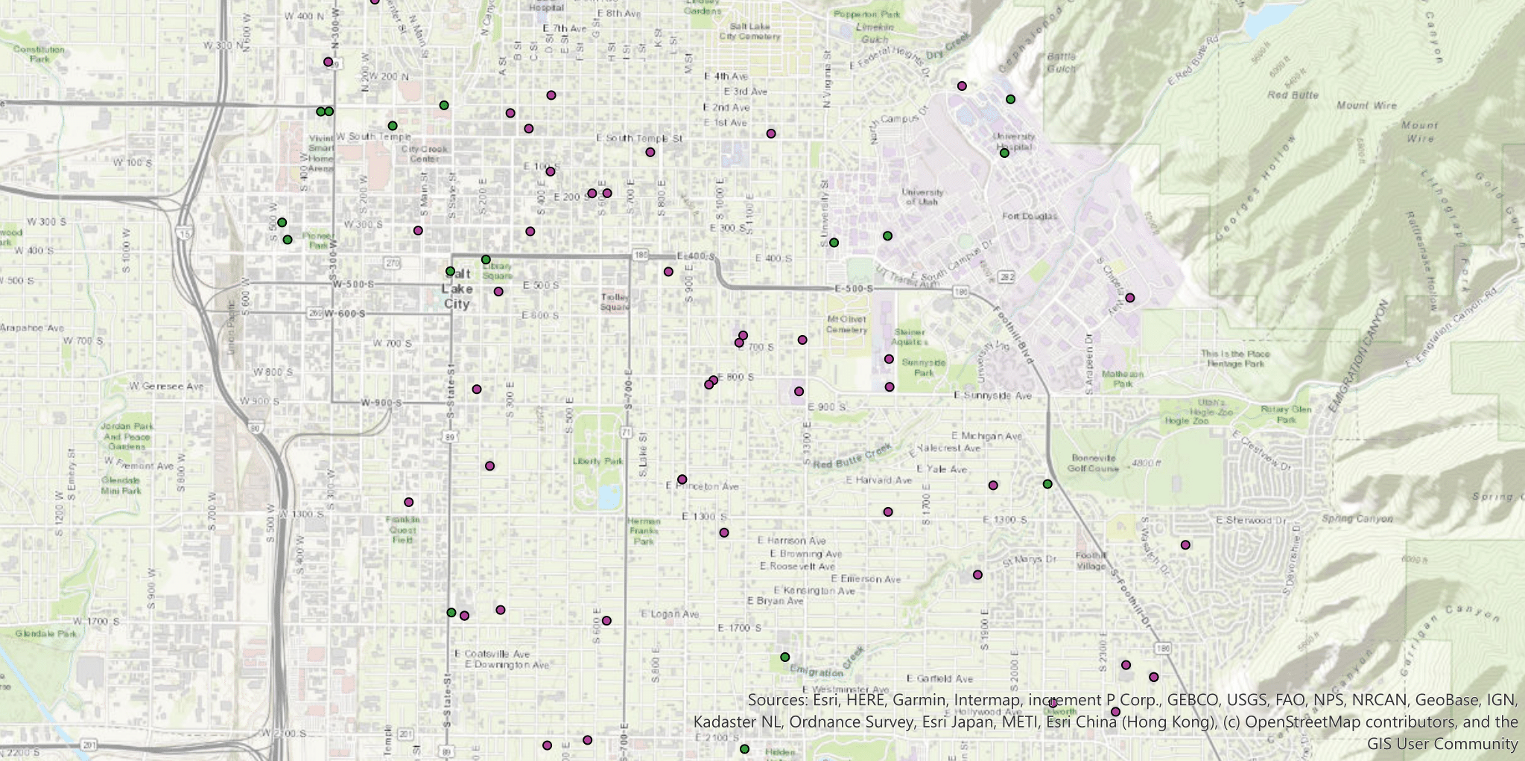

- Examine attribute information contained within the point features using both pop ups and attribute tables. Create a list of all schools offering only grades 9 through 12.

- THE AMERICAN ACADEMY
- EAST HIGH
- HIGHLAND HIGH
- REALMS OF INQUIRY
- JUDGE MEMORIAL CATHOLIC HIGH
- ROWLAND HALL-ST MARK'S (SEC)
- SALT LAKE SCHOOL FOR THE PERFORMING ARTS
- INNOVATIONS HIGH SCHOOL

- Finally measure the straight-line distance from the Quinney Law Library to the Marriott Library.

Distance = 440.48 m.

- Open ArcCatalog and examine how the data is stored including the attributes and metadata. Record the information stated in the Summary of the Description tab.

Summary

To allow public Libraries to be located in Utah, as well as provide contact information and hours of operation.

Description

This dataset provides locations and information for public Libraries and their branches throughout Utah.

Last Update: June, 2013

